REGISTERED CHARITY NUMBER: 1207637



Report of the Trustees and
Unaudited Financial Statements for the Year Ended
31st March 2025
For
TANGO2UK

CONTENTS OF THE FINANCIAL STATEMENTS FOR THE YEAR END 31ST MARCH 2025

Report of the Trustees Page 3 – 12
Achievements to date Page 13
Moving forward Page 14
Declaration Page 15
Statement of Financial Activities Page 16
Balance Sheet Page 17

TRUSTEES’ ANNUAL REPORT (Incorporating Trustees Report)
For the year ended 31st March 2025
Reference and Administrative details
Registered Charity name: Tango2UK Charitable Incorporated Organisation (CIO)
Registered Charity number: 1207637
Registered Office: 10 Park Road
Leamington Spa
Warwickshire
CV32 6LG
Trustees
Co-Founders and Trustees Dr Hannah Packman & Tim Driffill
Trustee – Governance Deb Gunn
Trustee – Treasurer Guy Boulding
Trustee – Appointed Jan ’25 Amanda Hull

Bank Co-operative Bank plc.

Trustee’s Statement

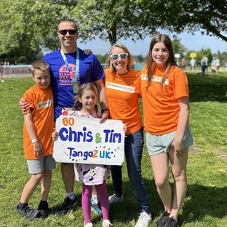
This year marks the publication of the very first Annual Report for Tango2UK.

Tango2UK was founded after our family had first-hand experience of receiving a TANGO2 diagnosis in our youngest daughter. Phoebe was lucky to have never experienced a metabolic crisis, but we had years of unexplained symptoms and delays to her care before we finally received a diagnosis age 6 years old. We immediately recognised how important a UK based charity and advocate for families within the NHS would be. Because of this we founded Tango2UK.

In the short period of time since we were established, we are amazed at what has been achieved. We are a small but passionate UK charity dedicated to supporting families affected by TANGO2-related deficiency disorder. This is an incredibly rare metabolic genetic disorder with only 14 diagnosed cases in the UK currently. Since our recent launch this has been a year of both remarkable progress and vital foundation-building — establishing strong processes, partnerships, and a growing community.

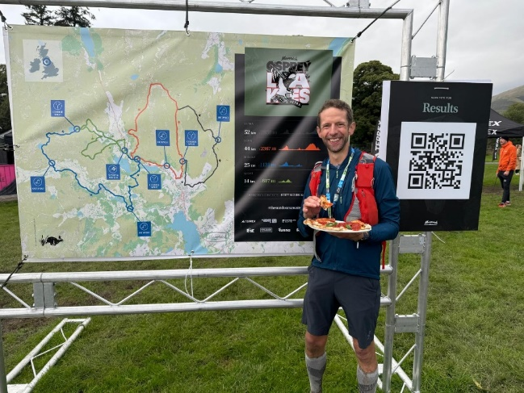
We are incredibly proud to share that, thanks to the tireless efforts of families, friends, and charitable partners, over £20,000 has been raised this financial year, April 2024-25. From running, swimming and cycling challenges to parties and mud-filled adventures, every supporter has played a crucial role in helping us reach our goals — supporting affected families and driving forward essential research.

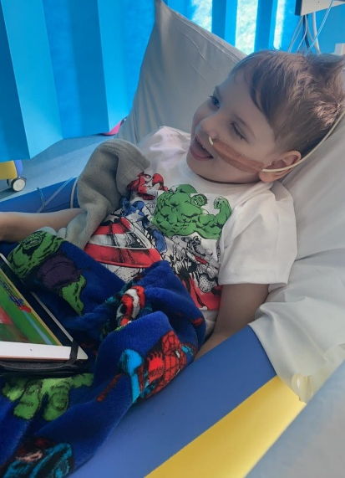
One of our most significant achievements has been improving the pathway to diagnosis. By successfully advocating for the inclusion of the TANGO2 gene in multiple relevant symptom gene panels, two children have already received earlier diagnosis than previously possible. Greater recognition of the wide range of symptoms linked to TANGO2 deficiency has been instrumental in enabling this crucial step forward.

We have also strengthened our research collaborations, working closely with clinicians and researchers in Manchester. Together, we have supported the first UK case review series focusing on children diagnosed with TANGO2 deficiency. We are thrilled that this important work will be presented next year at the Paediatric Neurology Conference in Glasgow — a wonderful opportunity to raise awareness within the clinical community.
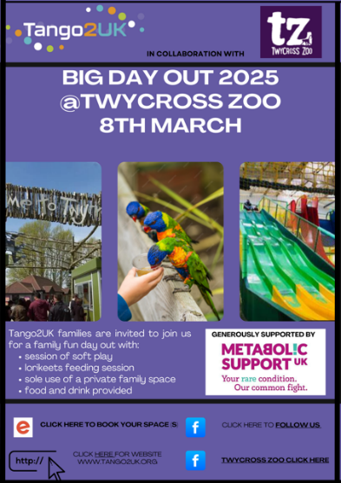
A true highlight of the year was our first-ever family event, welcoming families from across the country for a special day at the zoo in March 2025. For many, it was the first time meeting others who understand the TANGO2 journey. Seeing children, siblings, parents and carers come together — sharing experiences, joy and support — was incredibly moving. This will be the first of many events focused on building a stronger, connected community and understanding the common needs of our children.

None of this would have been possible without our outstanding supporters. We are deeply grateful for your energy, generosity and unwavering belief in brighter futures for our rare children.

Thank you for helping us make a real difference — and for walking beside us as we continue to push forward with hope, determination and care.

With warm regards,

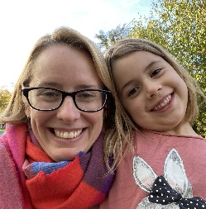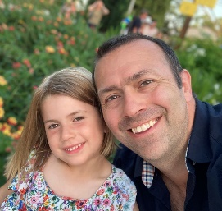
Hannah Tim Deb Guy

STRUCTURE, GOVERNANCE AND MANAGEMENT
The charity is controlled by its governing document, a deed of trust and constitutes an unincorporated charity.
The charity was registered on the 27th March 2024 as a charitable trust and was set up by a Trust deed. The charity is registered with the Charity Commission.
RECRUITMENT AND APPOINTMENT OF NEW TRUSTEES
The Management of the charity is the responsibility of the Trustees who are elected and co-opted under the terms of the Trust deed.
New trustees may be appointed by the existing trustees and serve for a term of three years after which they are eligible for re-appointment. The Constitution provides for a minimum of three trustees and a maximum of twelve trustees. On appointment, and as set out in our Constitution, a new trustee will be sent a pack including the Tango2UK Constitution, all policies and the Charity Commission guidance ‘The Essential Trustee: What You Need to Know’, and, once we have been in existence for long enough previous accounts and reports.
GOVERNANCE AND RISK MANAGEMENT
The Trustees are responsible for the overall management and control of Tango2UK and met 8 times during the year with an average level of 94% attendance. All trustees give their time freely and no remuneration was paid in the year, details of trustee expenses are disclosed in the accounts at Appendix 1. Trustees are required to disclose all relevant interests and register them with the trustee group as a whole and, in accordance with the Constitution, withdraw from decisions where a conflict of interest arises. All decisions are made at the meetings and recorded in the minutes accordingly.
At meetings, the Trustees agree the broad strategy and areas of activity and fundraising for the Charity, including but not limited to fundraising activities, activities to support our TANGO2 families and grow the Tango2UK community, clinical connections and developments, research leads and the related funding, governance and finances and commission of external expertise.
Amanda Hull was added to the Trustee group on 17th January 2025 and there have been no changes to the Constitution.
The Trustees have considered the major risks to which the charity is exposed and are constantly reviewing those risks and putting systems in place to manage those risks. One operational risk we face is an ever-increasing workload and where appropriate, the Trustees have taken the decision to outsource certain projects to a specialist charity consultant who can better serve the charity with grant applications and supporting new areas.
Another area of risk is to ensure we are reaching and engaging with families affected by TANGO2 in the UK – as one of our constitutional objectives we are continually working on ways to grow this, including family away days/weekends, WhatsApp groups, virtual meetups and a yearly update.
We have struggled to make headway with research avenues in the UK and so are looking for ways we can donate to Tango2UK Research Foundation (USA) to specifically support research later in 2025.
Raising clinical awareness is also ongoing and we are looking for key contacts in the UK to progress this. A big section on the website dedicated to clinician resources has been developed and the Trustees are looking at ways to forge new connections in this area.
OBJECTIVES AIMS AND PUBLIC BENEFIT
The objects of the CIO are to preserve and protect good health for the public benefit of people suffering from Tango 2 and their families by:
- Providing advice, support and information to TANGO2 affected patients and their families.
- Providing or assisting in the provision of information to the public about the condition TANGO2 deficiency disorder.
- Supporting, providing or assisting health education and social care professionals in their understanding of TANGO2, its diagnosis, prognosis, and treatment.
- Supporting research into the condition, TANGO2 causes and the means to improve the outcomes for those suffering with the condition and promoting the dissemination of the useful results of such research
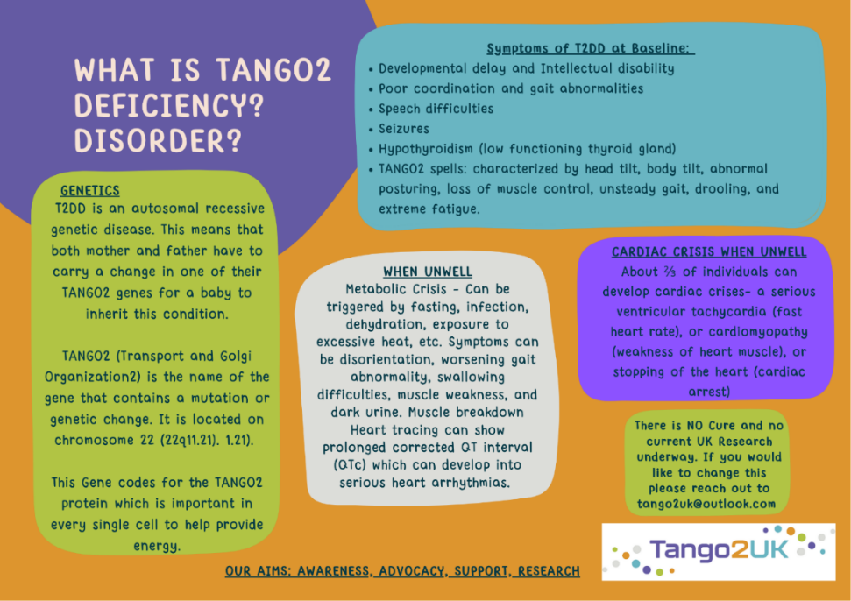
- Providing information and sharing developments in TANGO2 care and research with other TANGO2 charities but not limited to the UK.

OPERATING ACROSS THE UK
Tango2UK charity operates across the UK.
CLASSIFICATION OF CHARITY

Tango2UK beneficiaries (WHO):
Children and adults diagnosed with TANGO2-related disorder, along with their families and carers. Beneficiaries also include clinicians who need greater awareness and understanding to better identify and support those affected.

Tango2UK operational method (HOW):
By driving awareness, support, and research:
- Awareness: With only a handful of UK children currently diagnosed—despite potentially thousands living with TANGO2 worldwide—we promote clinical awareness so clinicians can recognise symptoms earlier, helping individuals avoid metabolic crises and enabling families to access timely care.
- Support: TANGO2 diagnoses often arrive suddenly, sometimes during serious hospital admissions or after years of unexplained symptoms. We provide families and carers with vital information, connection, and emotional support so they are not left isolated following such a life-changing diagnosis.
- Research: For any rare disease, research is essential to understanding the condition and improving outcomes. We work to drive UK-based research that will lead to better management, improved quality of life, and ultimately a cure for TANGO2 deficiency disorder.

Tango2UK purpose (WHAT):
To raise clinical and public awareness, provide essential support to individuals, children, families, and carers, and advance research so that everyone affected by TANGO2—and the clinicians who care for them—can access the understanding, treatment, and hope they deserve.
TANGO2UK SAFEGUARDING
Safeguarding remains central to TANGO2 UK’s mission, ensuring the wellbeing and safety of all our beneficiaries—including children, adults, families, carers, and those who support them. Our safeguarding policy is reviewed annually and provides clear guidance to trustees, staff, and volunteers, all of whom receive appropriate training to uphold the highest standards of protection. We strive to create a safe, respectful, and dignified environment where every individual feels supported and secure. Safeguarding is embedded across all our activities, from family support to awareness and research initiatives. Our commitment to safeguarding not only fulfils our legal and ethical responsibilities but also strengthens the trust that families place in Tango2UK to protect those who are most vulnerable and at the heart of why our charity exists.
TANGO2UK’S BOARD DIVERSITY/LIVED EXPERIENCES
Tango2UK is led by a highly experienced and deeply committed board whose collective expertise and lived experience shape every aspect of the charity’s direction. Our founders, Tim and Hannah, bring invaluable first-hand insight as parents to their daughter, Phoebe, who lives with TANGO2-related disorder. Their experience navigating the challenges of diagnosis, treatment, and ongoing care has given them a profound understanding of the gaps in service provision, the urgent need for research, and the realities faced by families across the UK. Hannah is also an NHS Doctor and practicing GP which helps provide a clinical understanding, support and awareness of services to the team. They are joined by Amanda, also a parent of a child with TANGO2, whose lived experience further strengthens the board’s ability to remain grounded in the needs of those we support. Amanda works as an Educational Psychologist and has deep understanding of the challenges families with additional needs may experience within school and health care settings. Complementing this lived experience are trustees Guy, who works in the financial sector, and Deb, a trainee solicitor. Both bring vital professional expertise—ensuring strong governance, financial oversight, and legal compliance. Together, this diverse board ensures that Tango2UK is not only professionally robust but firmly rooted in real-world experience, ensuring decisions are informed, compassionate, and deeply aligned with the needs of the TANGO2 community.

TANGO2UK – ACKNOWLEDGMENTS

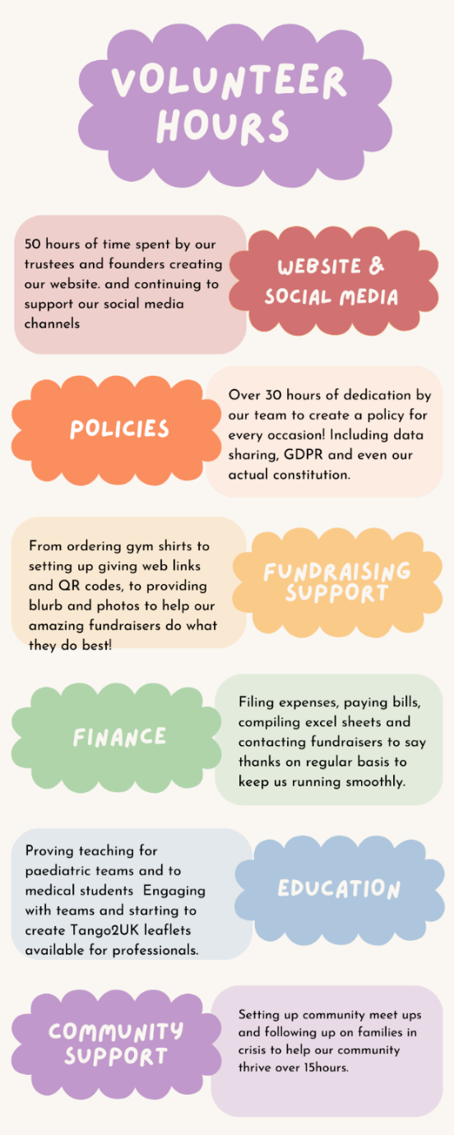

We’re also proud to be building strong partnerships with Genetic Alliance UK, Metabolic Support UK, and Croft Medical Centre, whose guidance and collaboration help drive our work forward. A special thank you to Base 8 Innovations for their invaluable support in managing our website, and to Twycross Zoo for generously enabling us to hold our first family event as a gift in kind. We’re equally grateful to Rare Revolution Magazine for offering us a social media takeover, helping us broaden our reach and raise vital awareness.

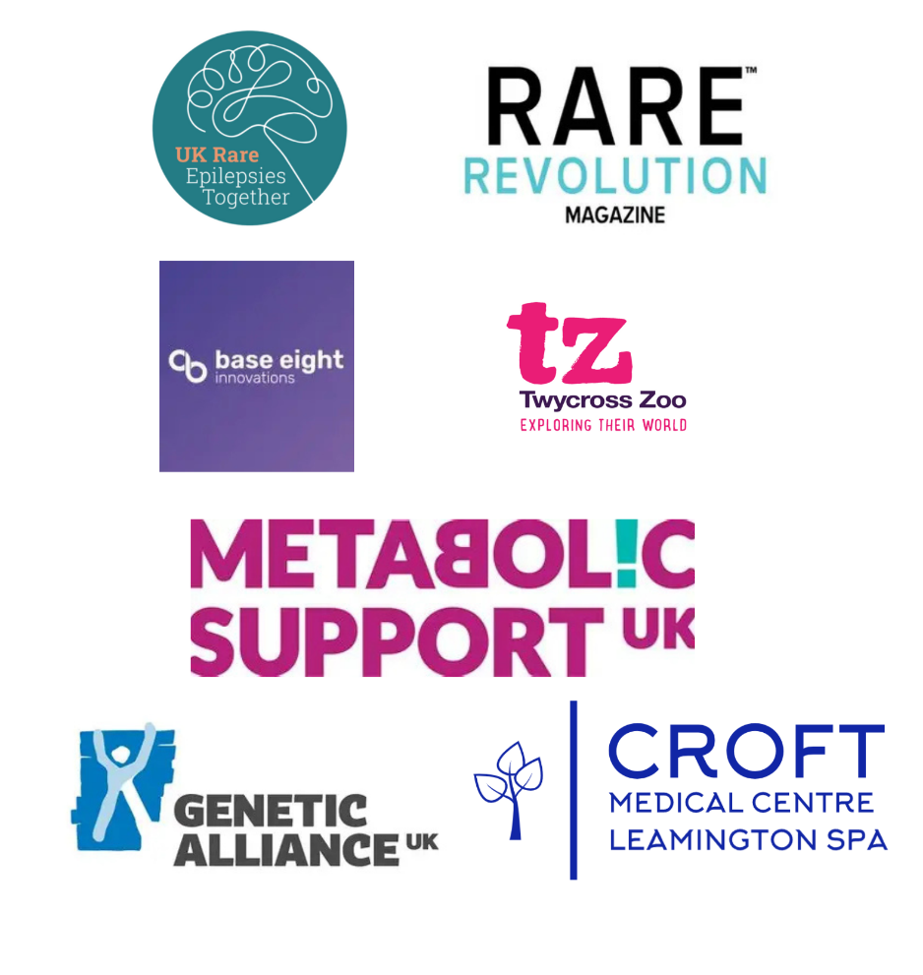

We’re also incredibly proud that, thanks to the tireless efforts of families, friends, charitable partners, and dedicated fundraisers, £20,374 has been raised this financial year. From running, swimming, and cycling challenges to cake sales, parties, and mud-filled adventures, every effort has played a crucial role in building the foundations to support affected families and drive forward essential research.

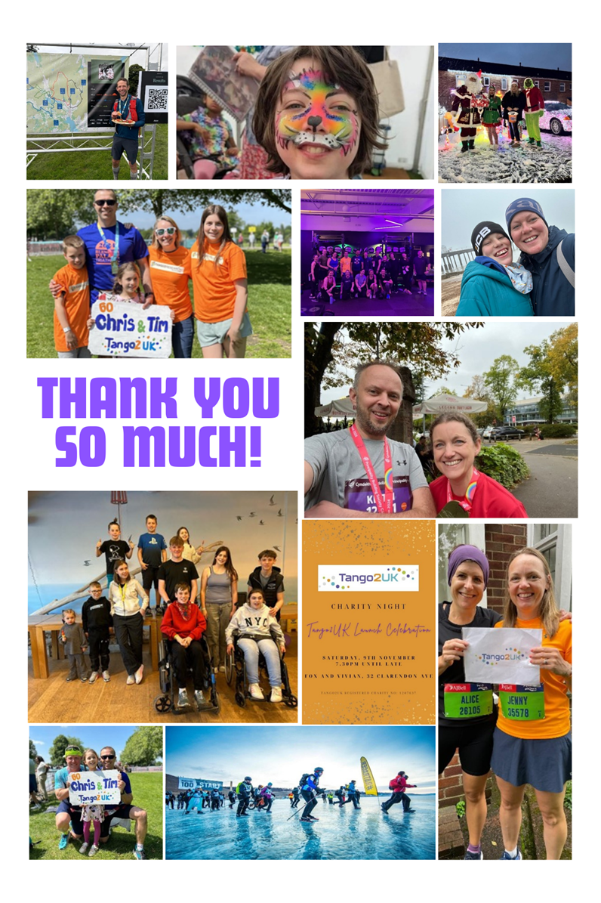

FINANCIAL REVIEW – RESERVES POLICY

Purpose: The purpose of this reserves policy is to ensure the financial stability of Tango2UK and to protect the charity's ability to meet its obligations in the event of unforeseen circumstances.
Policy:
1. Initial Reserve:
Tango2UK will maintain an initial reserve of £3,000. This amount is set aside to cover minimal operating costs for approximately six months.
2. Annual Revenue Contribution:
In addition to the initial reserve, Tango2UK will allocate 10% of its annual revenue to the reserves fund. This contribution will continue until the reserves reach a level deemed sufficient to cover six months of operating costs, based on the charity's financial needs in that year.
3. Review and Adjustment:
The reserves policy will be reviewed annually by the trustees. Adjustments to the reserve amount and the percentage of annual revenue allocated may be made to reflect the growth and evolving needs of the charity.
Rationale: The reserves policy is designed to provide financial security and ensure that Tango2UK can continue its operations without interruption in the event of unexpected financial challenges. The initial reserve of £3,000, combined with the ongoing contributions from annual revenue, aims to provide a buffer that covers six months of minimal operating costs.
Monitoring: The reserves fund will be monitored regularly and reported to the Board of Trustees as required. Any changes to the policy or adjustments to the reserve levels will be made with the approval of the Board.
CONFLICT OF INTERESTS

Three of the Charity’s trustees are parents of a child diagnosed with TANGO2-related disorder. The Board recognises that this dual role may give rise to potential conflicts of interest. In accordance with the Charity’s Conflict of Interest Policy, which is reviewed on an annual basis, all trustees formally declare any personal or financial interests at the outset of each meeting. Any trustee with a declared conflict withdraws from related discussions and decision-making processes. These measures ensure compliance with Charity Commission requirements and safeguard the integrity, independence, and impartiality of the Board’s governance. The Board remains committed to ensuring that all decisions are made solely in the best interests of the Charity and its beneficiaries.

KEY ACHIEVEMENTS IN THE FIRST YEAR –
During the year 2024–25, Tango2UK made substantial progress in advancing its charitable purposes through targeted activities in awareness, research, community support, and fundraising. These achievements reflect the organisation’s commitment to improving clinical understanding, strengthening family support, and contributing to the evidence base for TANGO2-related disorder.
- Awareness
Tango2UK delivered teaching sessions across hospitals and a medical school to enhance clinical recognition and understanding of TANGO2-related disorder. The organisation successfully secured the inclusion of TANGO2 genetic testing within relevant diagnostic panels, supporting earlier identification of affected individuals. A dedicated website was launched to provide accessible information and guidance, and a Facebook support group was established and linked to wider rare disease networks to improve visibility and outreach.
- Research
Engagement with the Tango 2 Research Foundation (T2RF) in America was strengthened, and initial steps were taken to establish a Patient and Public Group to ensure lived experience informs future research priorities. Invitations were issued to clinicians to join a newly forming Clinical Board, contributing to a growing professional network. Tango2UK also collaborated with the team in Manchester to recruit families for a case review series, supporting the development of vital UK-based clinical insights.
- Community and Support
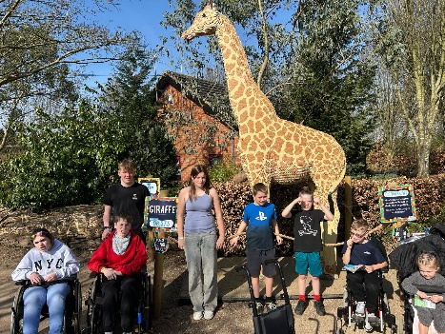
The charity delivered meaningful support to families throughout the year. A major family event at Twycross Zoo was attended by approximately 42% of families affected by TANGO2, helping to reduce isolation and strengthen connections across the community. Tango2UK provided direct support to two newly diagnosed children and their families during hospital admissions, ensuring they were not left without guidance at a vulnerable time. Family WhatsApp and Facebook groups were established to facilitate ongoing peer support and information sharing.
In addition, Tango2UK became a member of Genetic Alliance UK, enhancing its ability to engage in policy discussions, access sector-wide resources, and collaborate with the broader rare disease community. The charity also developed a positive working relationship with Metabolic UK, UKRET with Rare Revolution Magazine, increasing opportunities for awareness raising and external visibility.

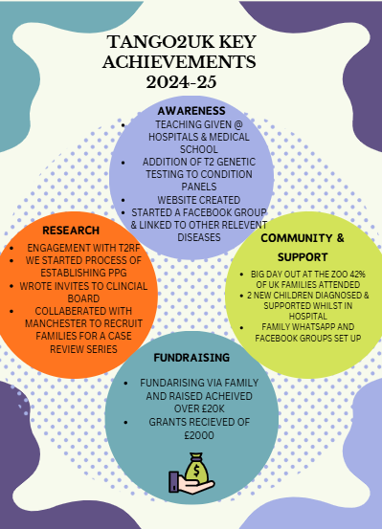

MOVING FORWARD

As Tango2UK continues to grow, we remain fully committed to our core priorities:
Raising awareness, supporting families, building a strong community, and perhaps most importantly, advancing research with the hope of future treatments.
We recognise both the exciting possibilities ahead and the natural challenges that come with being a young and developing charity. Our focus is on using every pound wisely, ensuring funding reaches the areas that will make the greatest impact for families as quickly as possible.

To achieve this, we are strengthening our clinical advisory board and establishing a Patient Participation Group (PPG). These voices will help guide research decisions and ensure that the real needs of our community remain at the centre of everything we do. While these structures are being finalised, we are actively supporting ongoing studies through our collaboration with TANGO2 Research Foundation (T2RF) based in America — ensuring that promising research continues to move forward. Our aim in 2025/26 is to be able to help fund valuable research through the foundation whilst also establishing UK- based research.

Because TANGO2 deficiency is so rare, many families face diagnosis feeling isolated and full of questions, while healthcare professionals may have limited knowledge of the condition. We are determined to change that. By bringing families together, we not only build friendships and support for carers, siblings and affected children — we also identify areas of need, such as access to psychological support.

We are excited to continue growing our national meet-ups and are already exploring the possibility of a full family weekend in the autumn of 2025 — another step in creating a connected, informed and empowered community.
Together, we will keep pushing forward — with hope, determination and the belief that progress is possible.
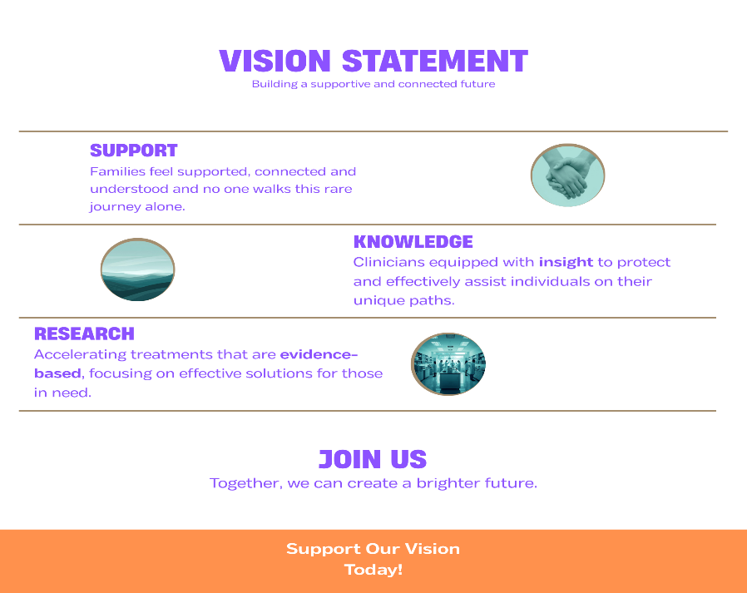
Reference and Administrative Details

Declaration and sign off by chair

Chair’s Statement of Approval:
The trustees confirm that this report sets out a fair review of Tango2UK’s activities and achievements during the year and reflects our commitment to supporting families and driving progress in research and awareness.

This report has been approved by the Board of Trustees and signed on their behalf:

Chair of Trustees: Tim Driffill

Signature: _____________________

Date: 21.11.25

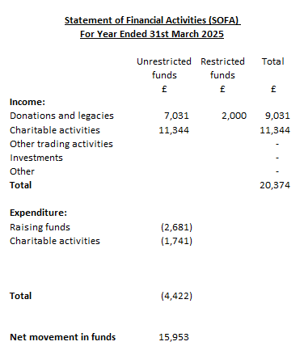

Note: Total Trustee Expenses Reimbursement is included in Charitable Activity expenditure

